**Blow out the RGB light**

In this experiment, we must be use USB data cable to plug in the RGB LED Circular expansion board interface. As shown in the figure below.

The battery is not enough voltage,it will affect the effect,such as color saturation of RGB lamp is reduced or microphone not work normally.

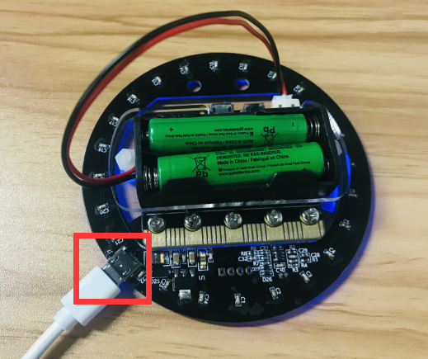

**Experimental phenomena:**

After the program is successfully downloaded, When we increase the sound or take a breath to microphone,the RGB lights will off.

Please see the mp4 video file for details.

